G7- UNIT 2 - Performance Tasks 1, 2, 3, 4

UNIT 2 – Performance Task 1
Assessment
Task 1 Student Directions:
The taxi fare in Atlanta is $2.40 for the first 1/2 miles and additional mileage charged at the rate $0.20 for each additional 0.1 mile. You plan to give the driver a $2 tip.

The Uber base fare is $1. There is a charge of $1.05 per mile. You also plan to give the driver a $2 tip.
Write an expression to represent the amount of money need to take a taxi or take Uber. (x = the number of miles.)
Create a table to determine how much it will cost to go 12 miles, 20 miles and 50 miles.
Which mode of transportation is better, use information from the table to support your answer?

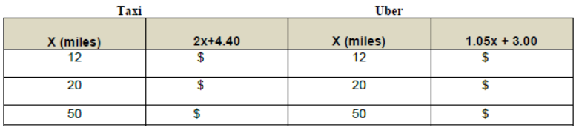

UNIT 2 – Performance Task 2
Task 2 Student Directions: While trying to determine which mode of transportation you were going to use in leaving the airport, you discovered Lyft was another mode of transportation. The base fare for Lyft is $1.35 and $0.95 per mile. You plan to give the Lyft driver a tip of $2. Determine the expression that represents the amount of money needed to use Lyft as your transportation service. (x = the number of miles).
You realize that you only have $10.00 left from you trip. You are trying to determine whether or not you have enough money to make it home using either Uber or Lyft service. Remember the expression for using Uber is 1.05x + 3.00. Write and solve an equation to determine the number of miles you can travel using Lyft and Uber.
Which company will allow you to travel the greatest number of miles?

UNIT 2 – Performance Task 3

Task 3 Student Directions: You were able to safely make it home from the airport. Your mother decided to give you $20 in January on your Lyft account so that you will not be in the same situation again. Each mile cost $0.95. The base fare is $1.35 and the tip will be $2.00 per trip.
Write and solve the inequality for each situation. Graph the solution to the inequality and write a sentence to describe the meaning of the solution. Round to the nearest hundredth.
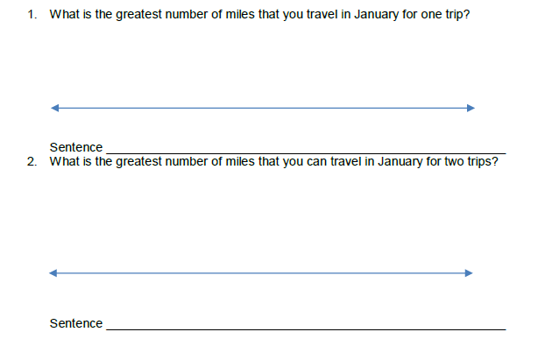
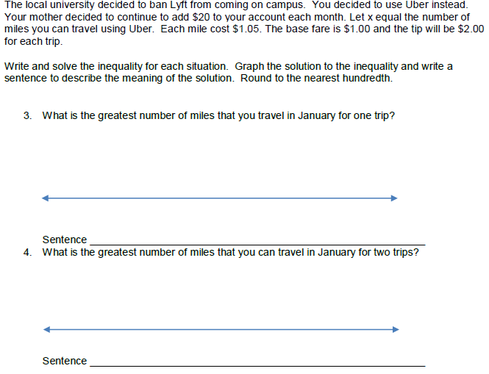

UNIT 2 – Performance Task 4

