Principal  Brenton Williams  Assistant Principals  Cagina Noird (6th Grade)  Kenneth Linsley (7th Grade)  Yolanda Cromer-Nunn (8th Grade/API)  Counselors  Dr. Mary Greene-Augusta (6th Grade)  Dr. Tiffany Stovall (7th Grade/Head Counselor)  Ardona Scott (8th Grade)  Administrative Staff  Amber Cooper, Front Office  Rita Garrard, Attendance Office  Donna Lessane-Smith, Counseling  Margie Riley, Displicine | Chamblee Middle School  3601 Sexton Woods Drive  ___  Chamblee, Ga 30341  ___  Phone: (678)874-8203  ___  Fax: 678-874-8210  ___  Chambleems.dekalb.k12.ga.us | 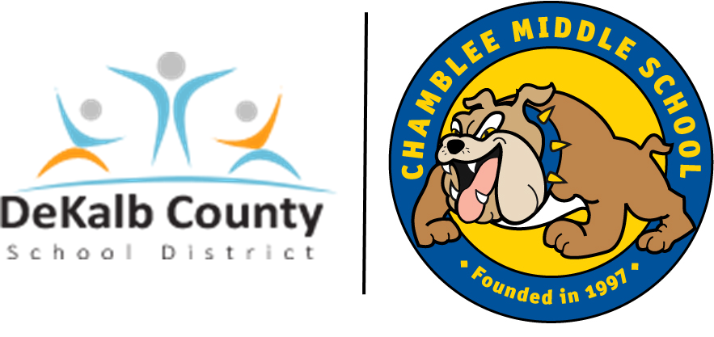  Chamblee Middle School  - The Chamblee Way  Respect  Integrity  Perseverance
Chamblee Middle School is one of the many DeKalb County Public Schools providing numerous high quality instructional programs. In addition to serving students who live in our attendance area, Chamblee Middle School also houses one of DeKalb’s two middle school Magnet Program for High Achievers.  Our academic excellence is illustrated by our consistent high scores on state and national tests and the numerous accolades and accomplishments of our students and faculty. Our highly qualified staff is committed to meeting the unique needs of the middle school learner. As a result, Chamblee Middle School provides:  - A curriculum that is relevant, challenging, integrative, and exploratory.  - Multiple learning and teaching approaches that respond to diversity.  - Assessment and evaluation programs that promote quality learning.  - Traditional middle school organizational structure that supports meaningful relationships and learning.  - School-wide efforts and policies that foster health, wellness, and safety.  - Multifaceted guidance and support services.  Students residing in the Ashford Park, Huntley Hills, Kittredge Magnet, and Montgomery Elementary attendance areas are eligible to attend CMS. We house 6th – 8th grades.  Chamblee Middle School offers a diverse curriculum which includes:  - Magnet Program for High Achievers  - Gifted Services  - ESOL  - Special Education Program  - Band, Art, & Orchestra Programs  - Foreign Language – Spanish & German  - Physical Education  - Technology & Business Education Courses  - GNETS  - STEAM Certified | Clubs & Activities  - Academic Bowl  - Basketball (6th, 7th, & 8th grade)  - Football (6th, 7th, & 8th grade)  - Cheerleading (7th & 8th grade)  - Robotics Club  - Helen Ruffin Reading Bowl  - Literary Magazine  - Math Team  - Track & Field  - Yearbook  - Softball  - Boys & Girls Lacrosse  - Baseball (6th, 7th, & 8th grade)  - Soccer (6th. 7th & 8th grade)  - Volleyball (6th, 7th & 8th grade)  - Student Council  - Social Butterflies  - Ecology Club  - Book Club  - Drama Club  - Dungeons & Dragons Club  - Peer Leaders  Additional Support  - 61 Classrooms  - Computer Lab  - Well equipped science lab  - 2 Campus Security personnel  - School Resource Officer  - Social Worker, Speech Pathologist, & School Psychologist  - Student Support Team/ Response to Intervention  - Keyless entry exterior doors  - Wireless computer capabilities  - Counseling Department  - School Leadership Team  - Administrator for each grade level  - Gymnasium & Fitness Room  - PSAT  - Instructional Support Specialist  - Paraprofessionals | Chamblee Middle School was founded in 1997 and moved into the current building in 2006. In Spring of 2023, Chamblee students scored 89.8 in Content Mastery (ELA/91, Math/88, Science/88, Social Studies/94), and 88.1 in Readiness.  Our 2023-2024 faculty and staff includes 62 highly qualified full-time teachers, a Media Specialist, a media clerk, an instructional technology support specialist, five paraprofessionals, three counselors, four administrators (one per grade level and principal), four administrative assistants, bookkeeper, registrar, one school Food Services manager and two assistants, one Plant Engineer, four custodial employees, a School Resource Officer (SRO), and two campus supervisors.  Our Values  Evert student is entitled to a quality education. High expectations produce high achievement. A safe, nurturing environment promotes optimal learning. Students, teachers, parents, counselors, and administrators share the responsibility of advancing the school’s mission.

